Solutions-at-Work or “SAW” serve as an informative resource highlighting an operational solution that a Mutual Member has implemented, or a vendor has available to reduce or eliminate risk in their work environment and reduce the risk to employees and the chance of injury. SAWs highlight our Members-Helping-Members culture to improve safety outcomes across our Mutual.
Expanding opportunities for higher education is vital for incoming candidates and existing safety personnel in the maritime industry, as it ensures a well-trained workforce capable of maintaining high safety standards. Our industry is challenged to identify qualified safety professionals due to limited availability of specialized educational programs. Increasing access to higher education and degree programs enables new entrants to develop essential skills, while experienced personnel can remain current with evolving safety regulations and best practices. Strengthening educational opportunities will help bridge the workforce gap and enhance overall maritime safety, reducing risks and improving operational efficiency.

Recognized Hazard:
The shortage of higher education programs results in a limited pool of candidates familiar with the maritime industry for open positions, making staffing a challenge, less effective risk management, and higher likelihood of preventable incidents.

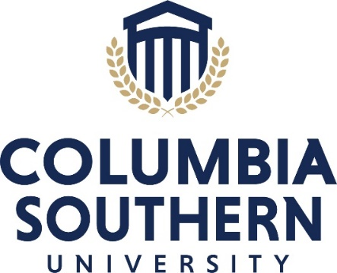
SAW Solution:
Signal Mutual has partnered with Columbia Southern University (CSU) to develop a safety and health curriculum specific to the maritime industry. These courses have been chosen by Signal Mutual Members and reflects what is most important to employers in the maritime industry when choosing a safety candidate. Columbia Southern University is the leader in occupational safety and health education. Taught by experienced safety experts, CSU’s online bachelor’s and master’s safety degree programs are recognized by the Board of Certified Safety Professionals as Qualified Academic Programs.

Visit ColumbiaSouthern.edu/OSH or call (877) 347-6050 to learn more.
Beginning October 2025, there will be two initial offerings, with a dedicated degree plan and graduate studies offered later:
- Bachelor of Science in Occupational Safety and Health with a Concentration in Maritime Safety
- Maritime Safety Certificate

Signal Mutual Members have exclusive benefits through our partnership with CSU in the form of a 10% learning partner tuition discount and waved application fees, as well as a yearly scholarship opportunity! More information on member benefits and Signal Mutual Scholarship can be obtained by visiting https://www.columbiasouthern.edu/signal-mutual/

Columbia Southern University is accredited by the Southern Association of Colleges and Schools Commission on Colleges (SACSCOC) to award associate, baccalaureate, master’s and doctorate degrees, and certificates. Questions about the accreditation of Columbia Southern University may be directed in writing to the Southern Association of Colleges and Schools Commission on Colleges at 1866 Southern Lane, Decatur, GA 30033-4097, by calling (404) 679-4500, or by using information available on SACSCOC’s website (www.sacscoc.org).

